Note Entry in PACS
While there will be different procedures for entering notes during the BOE process, the majority of our notes will be entered into the ‘Events’ section of PACS.
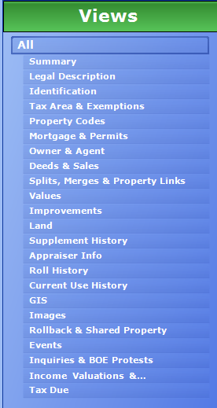
Clicking on the ‘Events’ button will bring us to the proper window. From here, you can see all of the events and contacts the Assessor’s Office has with the homeowner(s), as well as the relevant notes from Reval and New Construction.
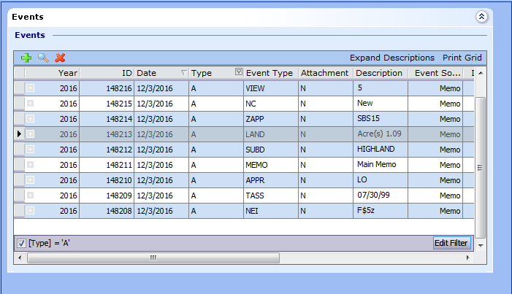
It is worth noting that the majority of the information currently in the Events dialog is legacy data from both ProVal as well as Tassess. You’ll recognize most of it from the various note headers that we used to select in ProVal.
You can double click any of the entries in the list and bring up the details of the note.
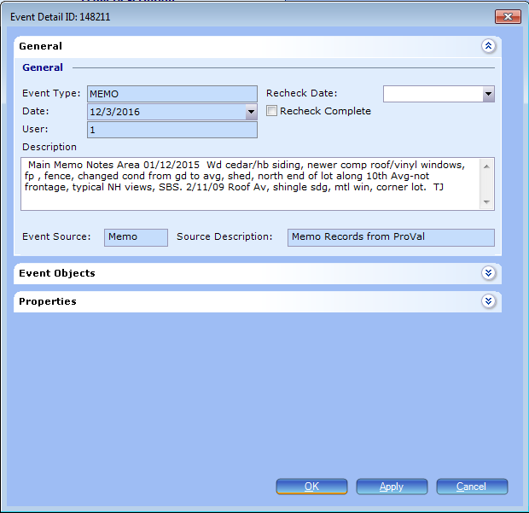
Notice that the information is currently in a copied and pasted format, and not the easiest to parse information from.
Moving forward we will use the following event for our notes:
- Appraiser Notes

Continue to start your notes with the date and end them with your three initials.
Note in the example above that the event type says REV, but the actual event type in PACS you will use is Appraiser Notes.
Creating a new event is as simple as selecting the green ‘+’ in the Events window. This brings up the following dialog box:

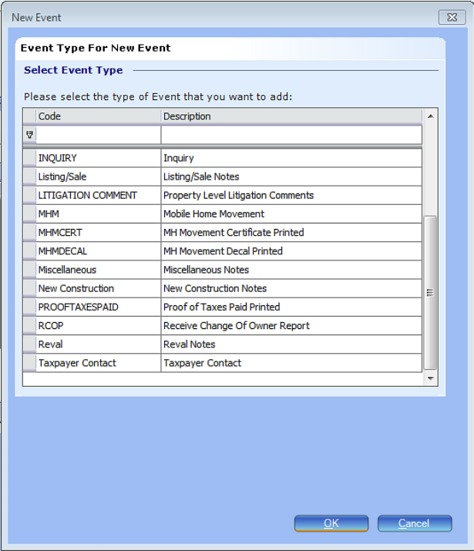
You will note that there are a lot of options. You will be able to view all events, but anything that you enter as notes will be within the event Appraiser Notes.
It is also important to reiterate that if an event type already exists, you do not need to create a new one, but rather add new information to the current one. So if you need to add something new to Appraiser Notes, you will just add it over the top of the notes that you already created.

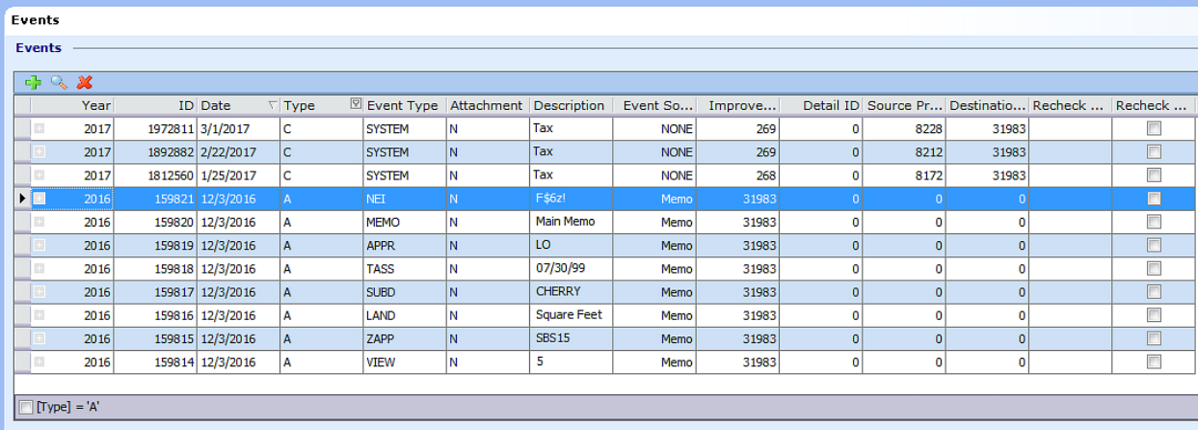
Note the “Type” column. A stands for appraiser and C stands for collections. You can click on the [Type] = ‘A’ button to hide the collections notes, and uncheck it to make them visible. There is no reason for you to ever edit a collections note. As a default, the [Type] = ‘A’ button should be checked.

There are other columns within each event, including Recheck Date and Recheck Complete that we are working on functionality with. They will likely become relevant in the future and you will be notified at that time how they will be used.

